***COMPLEX NETWORKS***

**EXERCISE 3**

*COMMUNITY DETECTION*

Enrique Molina Giménez

Alba Porras

12/04/2022

***Introduction***

In this exercise, the goal is to analyze communities in networks given as input of the exercise. Community detection of several networks (whose data are specified en .net – pajek files) will be studied in this paper.

The given networks to this exercise are:

* /toy : networks very little
* /real : networks that represent situacions of the real life
* /model : networks regular or networks that follows some pattern(s)

Several of this networks are accompanied by one or more .clu files, that represents the community aggrupation of nodes inside the networks.

The aim of practice is to the 3 .clu files more, in other words, apply 3 different community detection algorithms, and then compare different aggrupation proposals.

***Technological tools***

Several programming languages, programs and libraries are used in this exercise. In the next list we can see main technologies:

* Python as programming language, with networkx as graph library that allows manipulate graphs, draw them…
* Radatools, developed by URV tech, is a very flexible community detection software (also includes other functionalities) that allows combine different algorithms in a different ways.

***Explanation of the 3 community detection algorithms***

Three different algorithms must be used in this exercise (and these 3 algorithms must belong to two different applications).

Here we list these algorithms:

* **Type 1**: Clauset-Newman-Moore greedy modularity maximization algorithm. This algorithm is supported by Python networkx library.

As networkx documentation says: “*Greedy modularity maximization begins with each node in its own community and repeatedly joins the pair of communities that lead to the largest modularity until no futher increase in modularity is possible (a maximum)*”.

* **Type 2**: Combinated method for little networks (proposed in Radatools documentation): We can found in Radatools docs that the use of the type 'r-s-e-ll!rfr-trfr' is suggested for networks with no more that 1500 nodes. Almost all networks have less than this number of nodes. This algorithm use different heuristic in its process:
  + Reposition algorithm
  + Spectral optimization
  + Louvain algorithm
  + Fast algorithm
  + Tabu search

This sequence of algorithms executions is iterated 3 times for better calculations.

* **Type 3**: Louvain algorithm: is provided by Radatools. Also use optimization by modularity.  This means evaluating how much more densely connected the nodes within a community are, compared to how connected they would be in a random network.

***Distribution of project***

The files delivered in submit follows this distribution, and is explained here:

├───model : model given .net & .clu

├───radatools

├───real : real given .net & .clu

├───toy : toy given .net & .clu

├───images

├───comparison_indexes : txt files with Compare_Partitions output

├───modularity_calculations : txt files with Modularity_Calculation output

├───type1 : .clu files results of type1 executions

├───type2 : .clu files results of type2 executions

├───type3 : .clu files results of type3 executions

├───get_communities_type1.py : script to get type1 .clu results

├───get_communities_type2.bat : script to get type2 .clu results

├───get_communities_type3.bat : script to get type3 .clu results

├───get_all_comparison_indexes.bat

├───get_modularity_calculations.bat

├───definitions.py

└───plot.py : draw all network plots

Inspecting code we can show the implementation details of each community detection executions, but main behavior is explained in previous section.

***Results grouped by network***

**rb125**

***Modularity***

|  |  |
| --- | --- |
| rb125-1.clu | 0.80487805 |
| rb125-2.clu | 0.60975610 |
| rb125-3.clu | 0.60000000 |
| rb125-type1.clu | 0.74634146 |
| rb125-type2.clu | 0.73658537 |
| rb125-type3.clu | 0.73658537 |

***Indexes***

*Jaccard Index*

|  |  |  |  |
| --- | --- | --- | --- |
|  | rb125-type1.clu | rb125-type2.clu | rb125-type3.clu |
| rb125-1.clu | 0.6167 | 0.5833 | 0.5833 |
| rb125-2.clu | 0.2703 | 0.2857 | 0.2857 |
| rb125-3.clu | 0.2659 | 0.2811 | 0.2811 |

*Normalized Mutual Information*

|  |  |  |  |
| --- | --- | --- | --- |
|  | rb125-type1.clu | rb125-type2.clu | rb125-type3.clu |
| rb125-1.clu | 0.8450 | 0.8284 | 0.8284 |
| rb125-2.clu | 0.8119 | 0.8284 | 0.8284 |
| rb125-3.clu | 0.8089 | 0.8254 | 0.8254 |

*Normalized Variation of Information*

|  |  |  |  |
| --- | --- | --- | --- |
|  | rb125-type1.clu | rb125-type2.clu | rb125-type3.clu |
| rb125-1.clu | 0.1223 | 0.1381 | 0.1381 |
| rb125-2.clu | 0.2111 | 0.1952 | 0.1952 |
| rb125-3.clu | 0.2152 | 0.1994 | 0.1994 |

***Images***

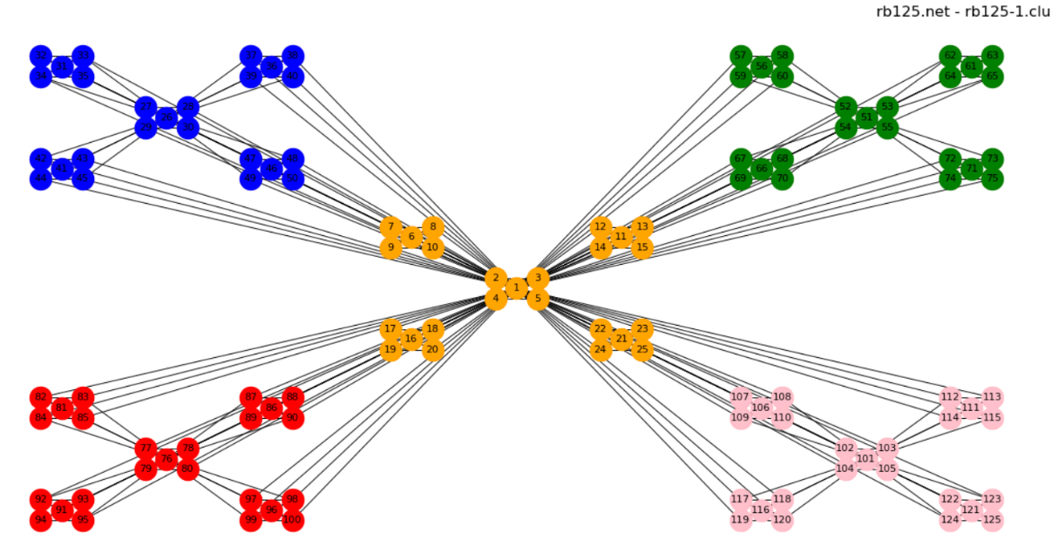

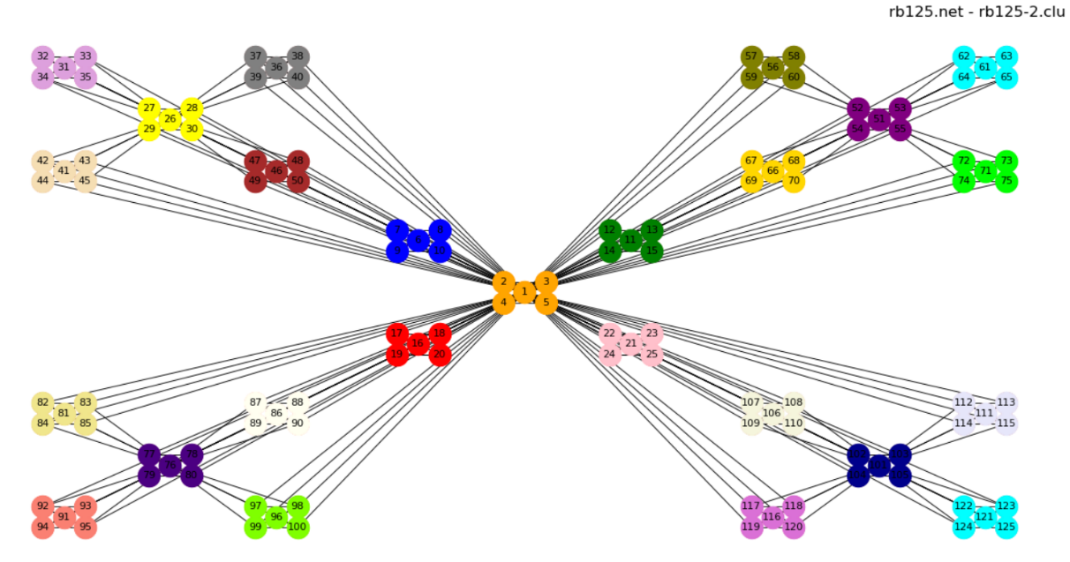

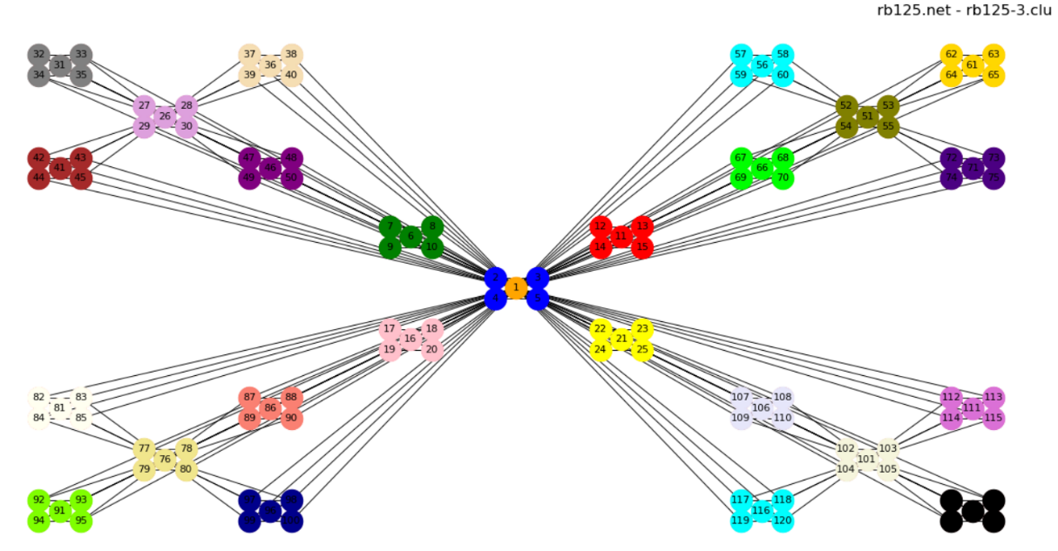

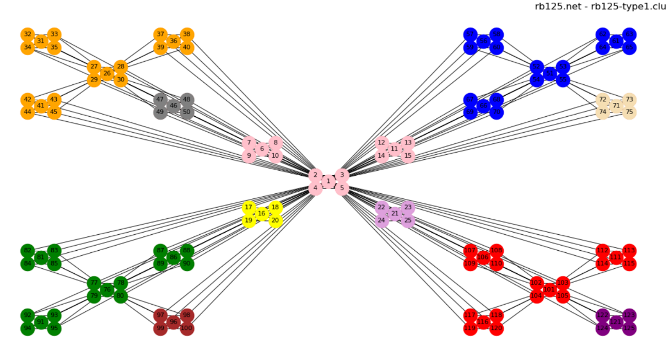

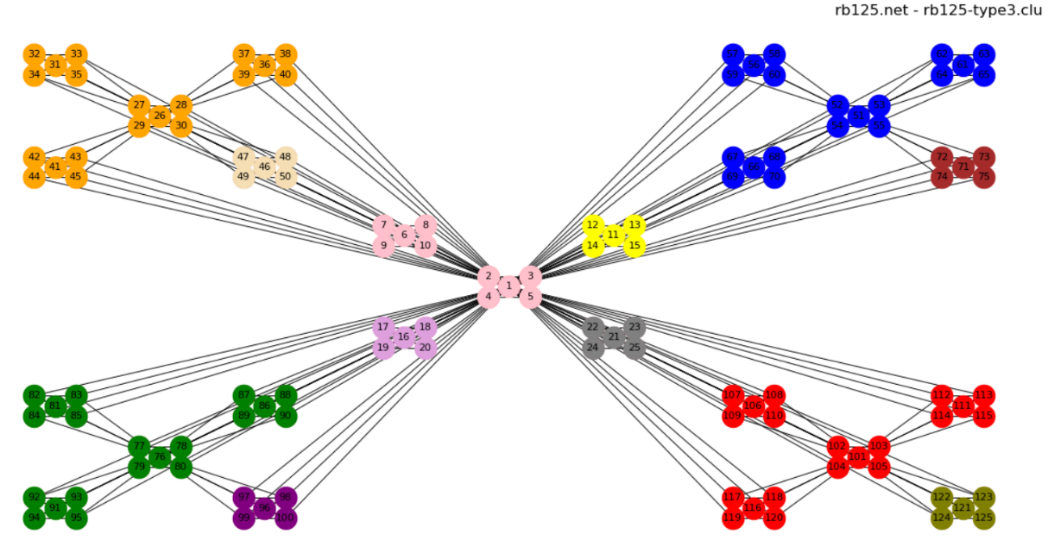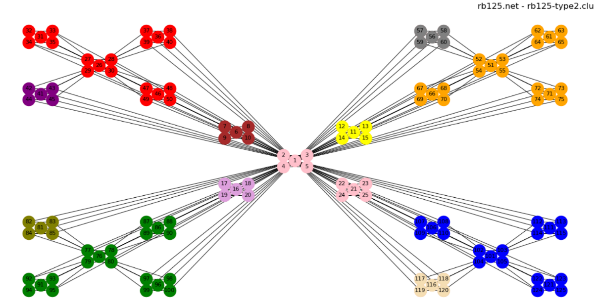

**256_4_4_2_15_18_p**

***Modularity***

|  |  |
| --- | --- |
| 256_4_4_2_15_18_p.clu | 0.84432718 |
| 256_4_4_2_15_18_p-type1.clu | 0.84432718 |
| 256_4_4_2_15_18_p-type2.clu | 0.84432718 |
| 256_4_4_2_15_18_p-type3.clu | 0.84432718 |

***Indexes***

*Jaccard Index*

|  |  |  |  |
| --- | --- | --- | --- |
|  | 256_4_4_2_15_18_p-type1.clu | 256_4_4_2_15_18_p-type2.clu | 256_4_4_2_15_18_p-type3.clu |
| 256_4_4_2_15_18_p.clu | 1.0000 | 1.0000 | 1.0000 |

*Normalized Mutual Information*

|  |  |  |  |
| --- | --- | --- | --- |
|  | 256_4_4_2_15_18_p-type1.clu | 256_4_4_2_15_18_p-type2.clu | 256_4_4_2_15_18_p-type3.clu |
| 256_4_4_2_15_18_p.clu | 1.0000 | 1.0000 | 1.0000 |

*Normalized Variation of Information*

|  |  |  |  |
| --- | --- | --- | --- |
|  | 256_4_4_2_15_18_p-type1.clu | 256_4_4_2_15_18_p-type2.clu | 256_4_4_2_15_18_p-type3.clu |
| 256_4_4_2_15_18_p.clu | 0.0000 | 0.0000 | 0.0000 |

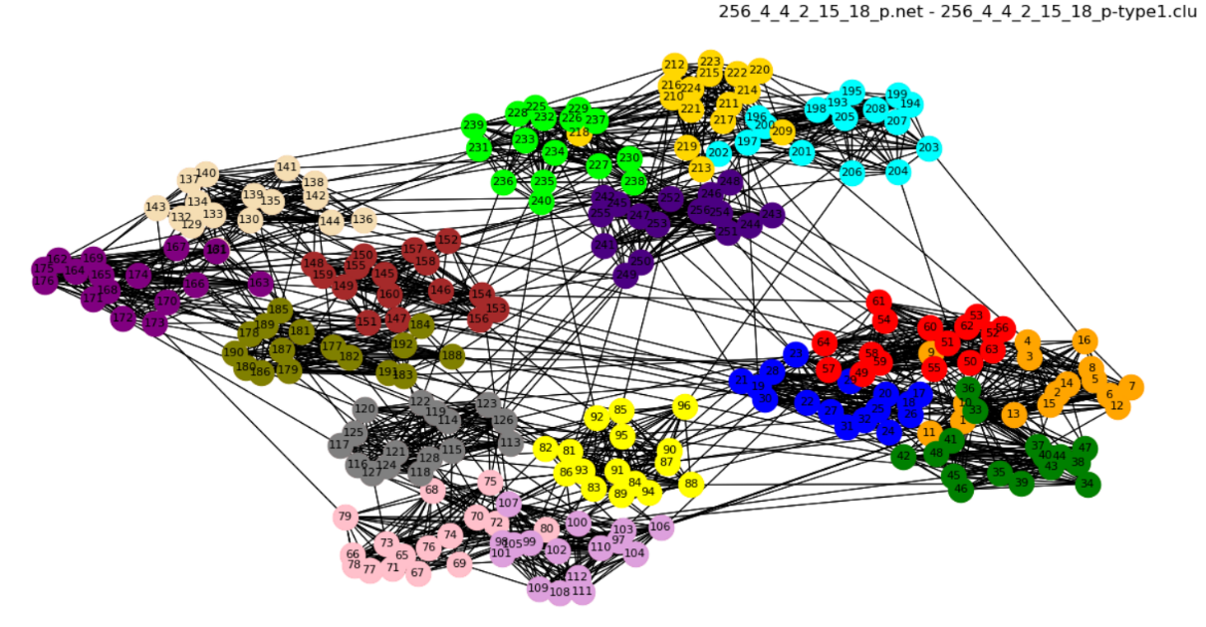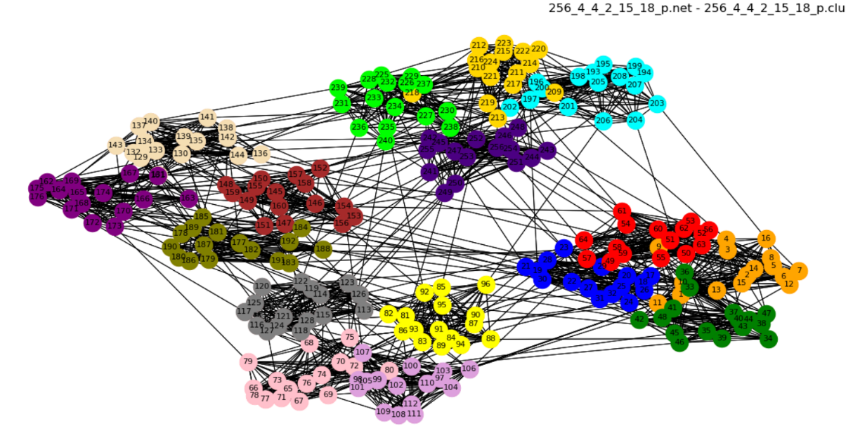***Images***

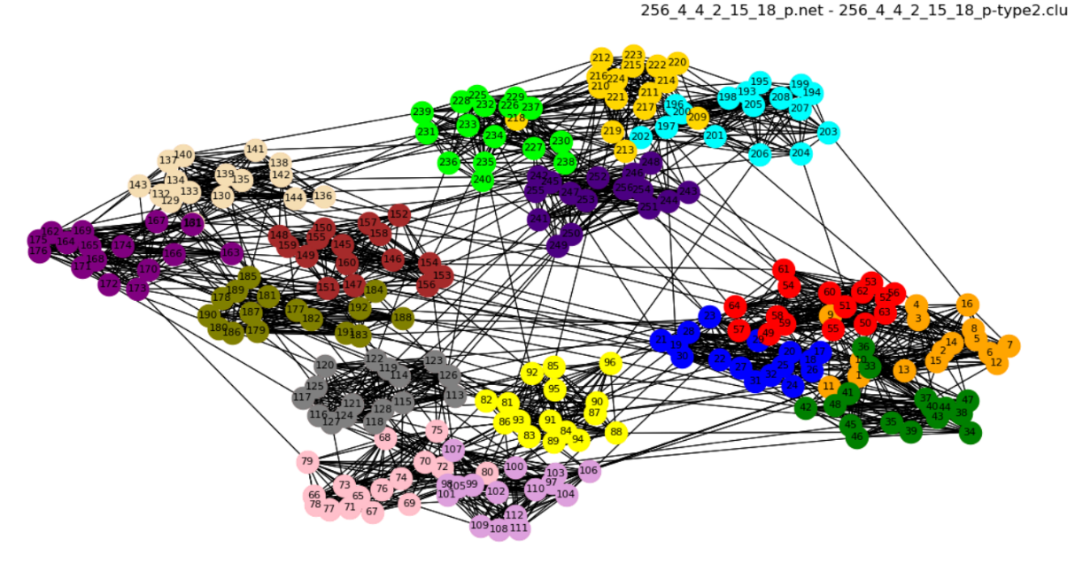

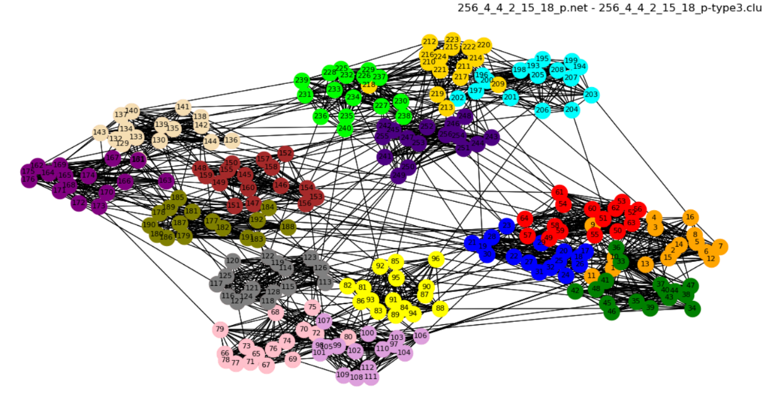

**256_4_4_4_13_18_p**

***Modularity***

|  |  |
| --- | --- |
| 256_4_4_4_13_18_p.clu | 0.94693345 |
| 256_4_4_4_13_18_p-type1.clu | 0.77990431 |
| 256_4_4_4_13_18_p-type2.clu | 0.92431492 |
| 256_4_4_4_13_18_p-type3.clu | 0.92431492 |

***Indexes***

*Jaccard Index*

|  |  |  |  |
| --- | --- | --- | --- |
|  | 256_4_4_4_13_18_p-type1.clu | 256_4_4_4_13_18_p-type2.clu | 256_4_4_4_13_18_p-type3.clu |
| 256_4_4_4_13_18_p.clu | 0.4591 | 0.9048 | 0.9048 |

*Normalized Mutual Information*

|  |  |  |  |
| --- | --- | --- | --- |
|  | 256_4_4_4_13_18_p-type1.clu | 256_4_4_4_13_18_p-type2.clu | 256_4_4_4_13_18_p-type3.clu |
| 256_4_4_4_13_18_p.clu | 0.7801 | 0.9517 | 0.9517 |

*Normalized Variation of Information*

|  |  |  |  |
| --- | --- | --- | --- |
|  | 256_4_4_4_13_18_p-type1.clu | 256_4_4_4_13_18_p-type2.clu | 256_4_4_4_13_18_p-type3.clu |
| 256_4_4_4_13_18_p.clu | 0.1410 | 0.0254 | 0.0254 |

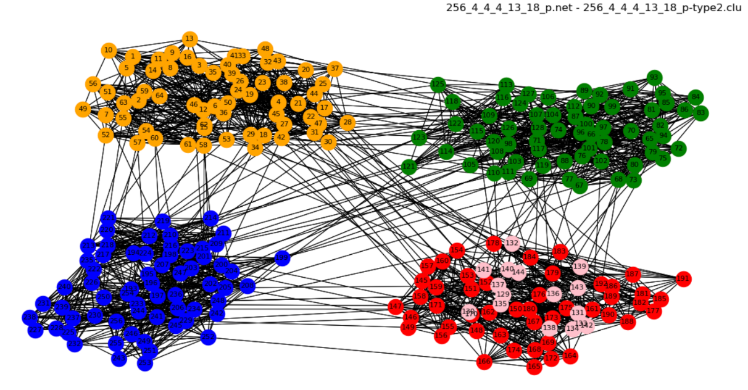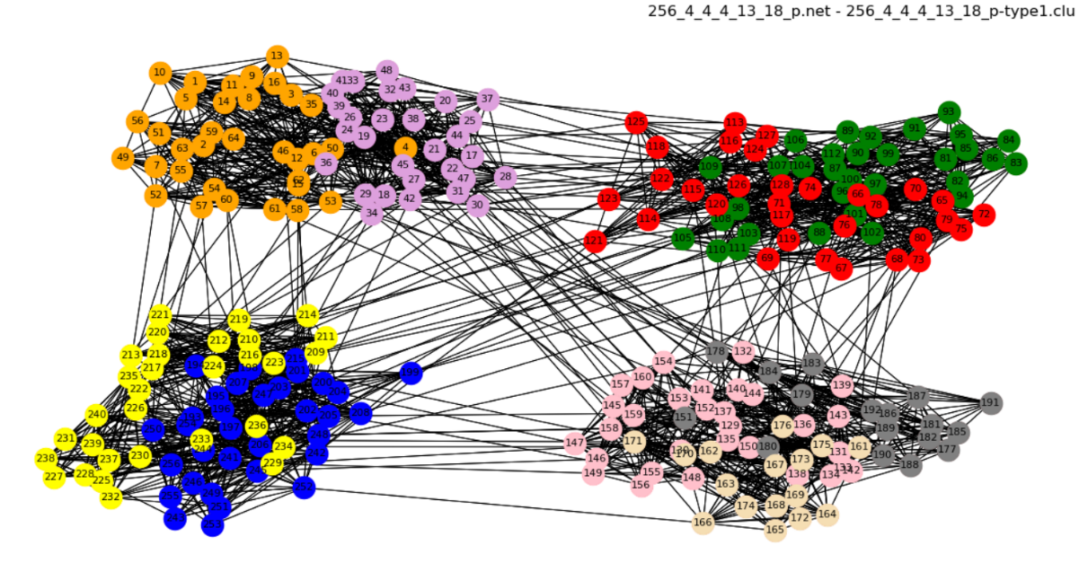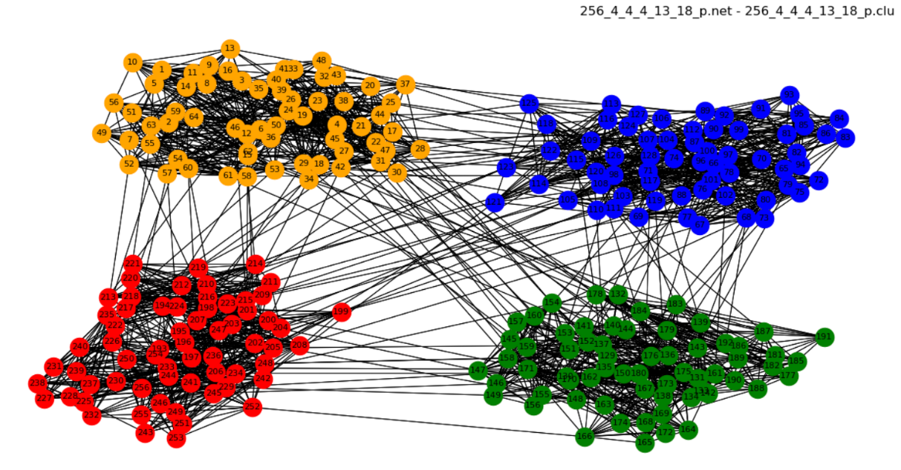***Images***

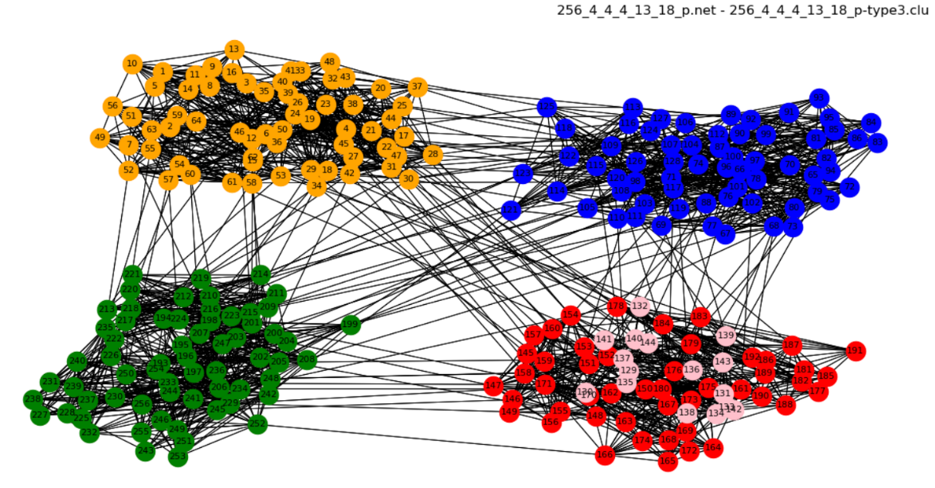

**airports_UW**

***Modularity***

|  |  |
| --- | --- |
| airports_UW-type1.clu | 1 |
| airports_UW-type2.clu | 0.86591455 |
| airports_UW-type3.clu | 0.86591455 |

***Indexes***

No comparisons because this network has no .clu files given as input of exercise

***Images***

**airports_UW.net – airports_UW-type1.clu**

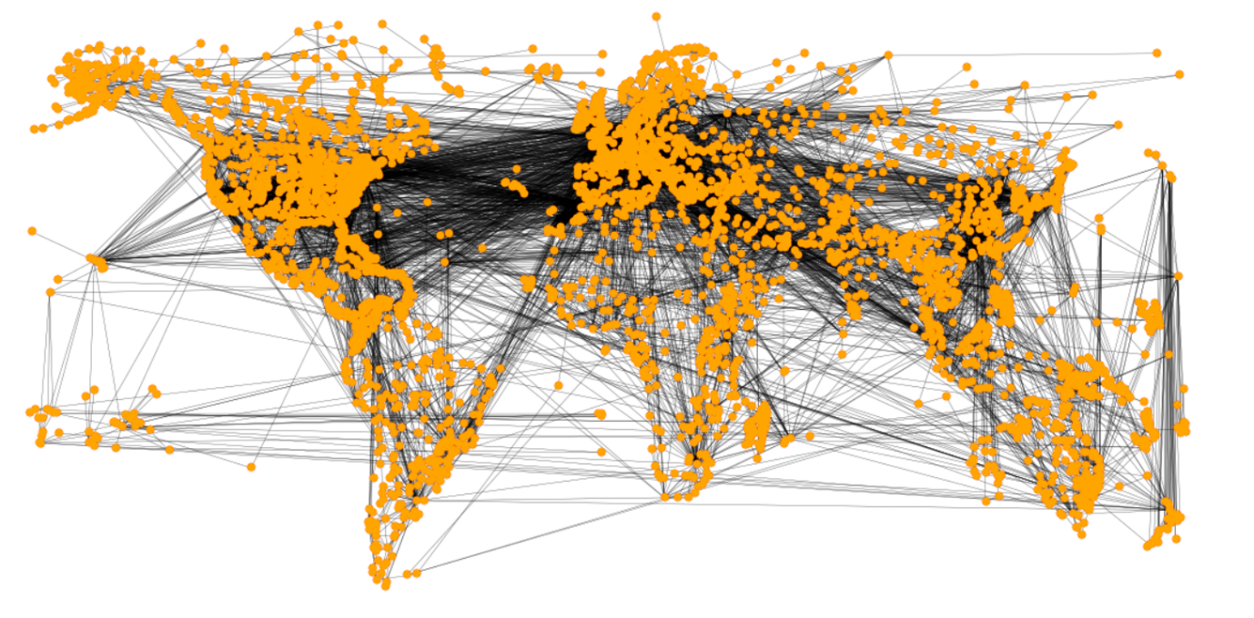

**airports_UW.net – airports_UW-type2.clu**

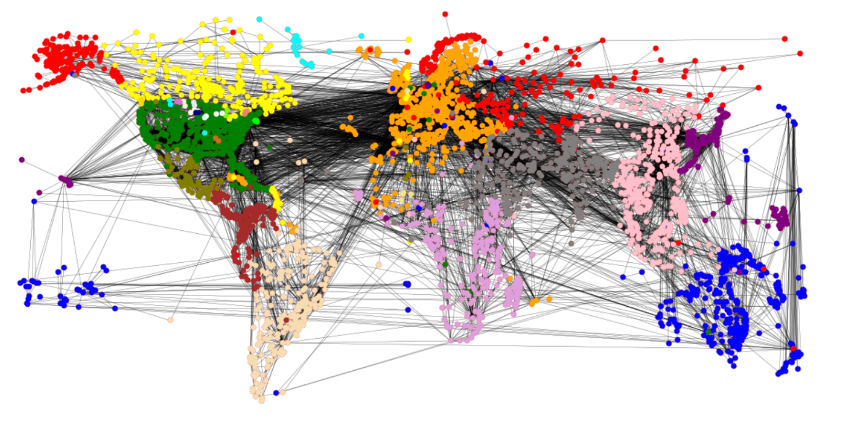

**airports_UW.net – airports_UW-type3.clu**

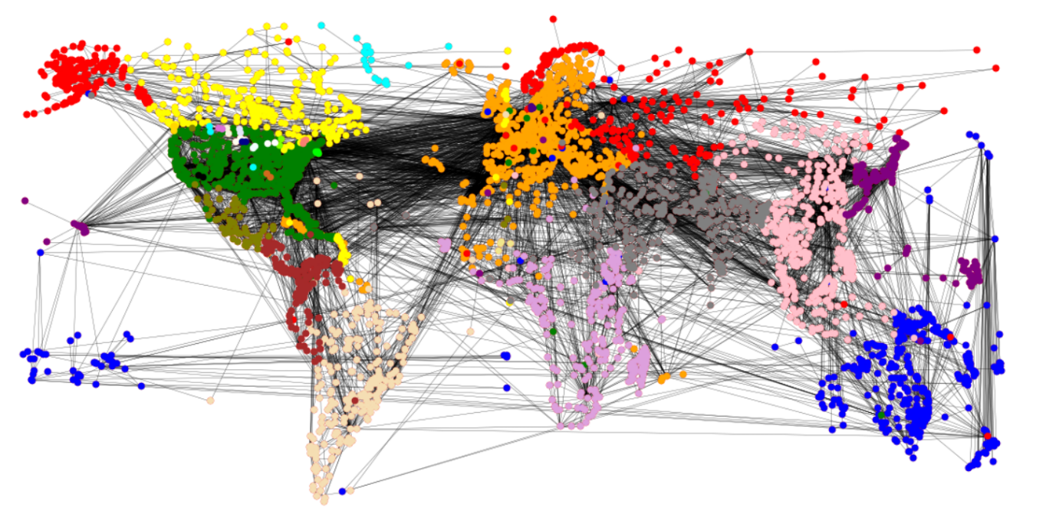

**cat_cortex_sim**

***Modularity***

|  |  |
| --- | --- |
| cat_cortex_sim.clu | 0.65371506 |
| cat_cortex_sim-type1.clu | 0.82685753 |
| cat_cortex_sim-type2.clu | 0.72119973 |
| cat_cortex_sim-type3.clu | 0.72119973 |

***Indexes***

*Jaccard Index*

|  |  |  |  |
| --- | --- | --- | --- |
|  | cat_cortex_sim-type1.clu | cat_cortex_sim-type2.clu | cat_cortex_sim-type3.clu |
| cat_cortex_sim.clu | 0.3847 | 0.6711 | 0.6711 |

*Normalized Mutual Information*

|  |  |  |  |
| --- | --- | --- | --- |
|  | cat_cortex_sim-type1.clu | cat_cortex_sim-type2.clu | cat_cortex_sim-type3.clu |
| cat_cortex_sim.clu | 0.4925 | 0.7807 | 0.7807 |

*Normalized Variation of Information*

|  |  |  |  |
| --- | --- | --- | --- |
|  | cat_cortex_sim-type1.clu | cat_cortex_sim-type2.clu | cat_cortex_sim-type3.clu |
| cat_cortex_sim.clu | 0.2437 | 0.1323 | 0.1323 |

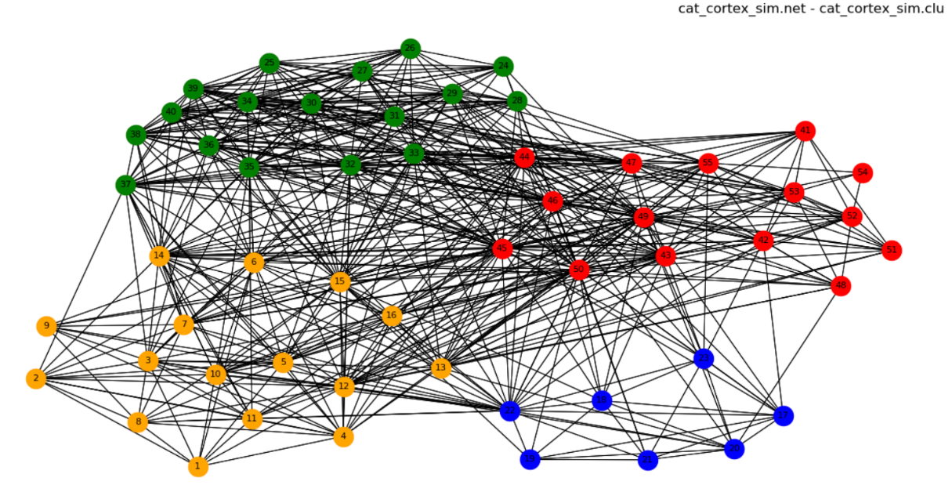***Images***

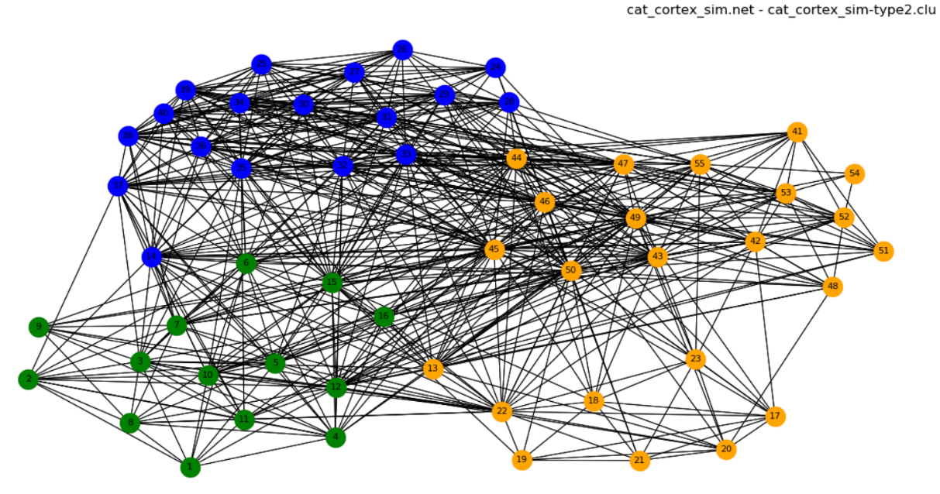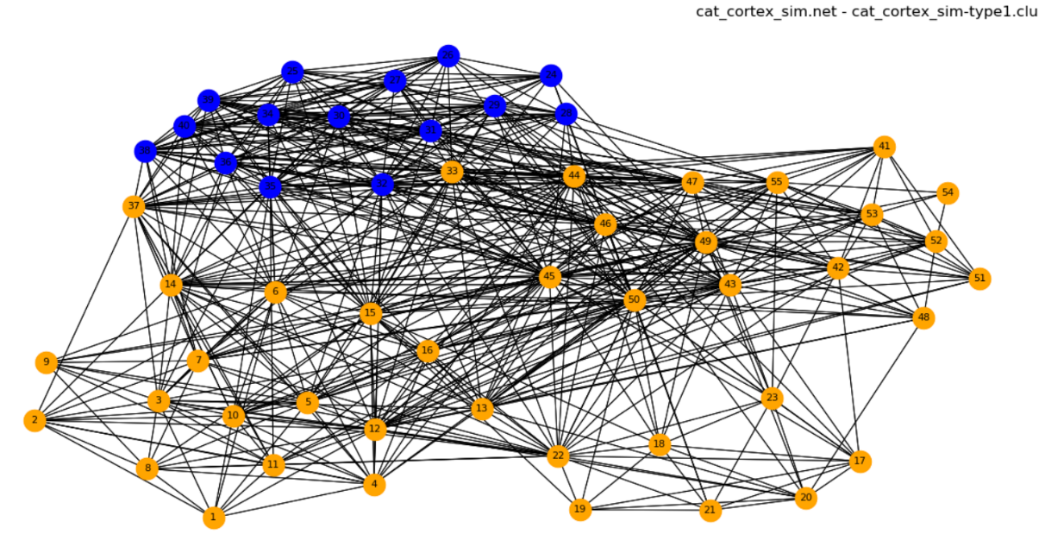

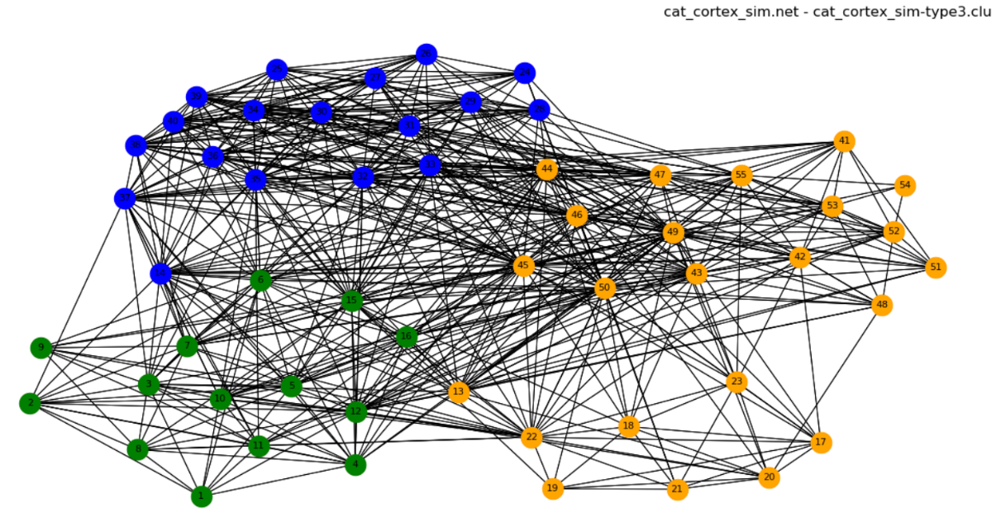

**football**

***Modularity***

|  |  |
| --- | --- |
| football-conferences.clu | 0.64274062 |
| football-type1.clu | 0.73083197 |
| football-type2.clu | 0.70799347 |
| football-type3.clu | 0.70799347 |

***Indexes***

*Jaccard Index*

|  |  |  |  |
| --- | --- | --- | --- |
|  | football-type1.clu | football-type2.clu | football-type3.clu |
| football-conferences.clu | 0.3622 | 0.7004 | 0.7004 |

*Normalized Mutual Information*

|  |  |  |  |
| --- | --- | --- | --- |
|  | football-type1.clu | football-type2.clu | football-type3.clu |
| football-conferences.clu | 0.6977 | 0.8903 | 0.8903 |

*Normalized Variation of Information*

|  |  |  |  |
| --- | --- | --- | --- |
|  | football-type1.clu | football-type2.clu | football-type3.clu |
| football-conferences.clu | 0.2675 | 0.1095 | 0.1095 |

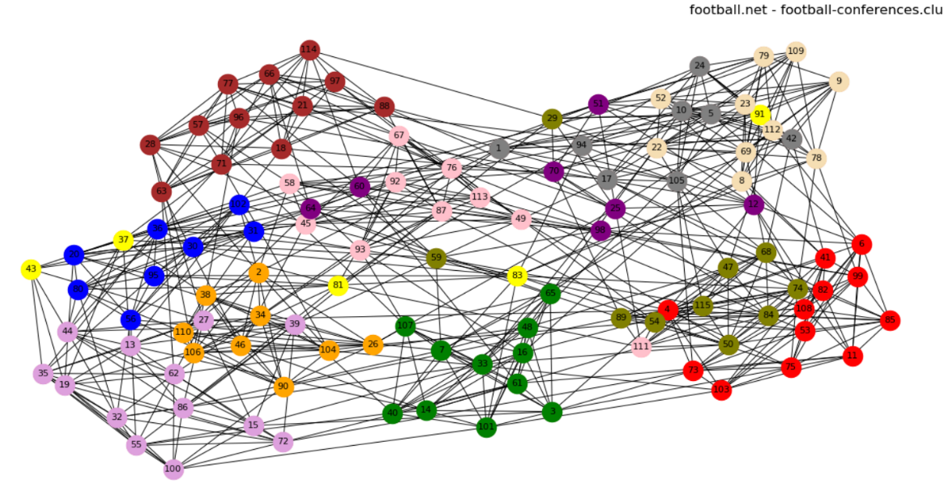***Images***

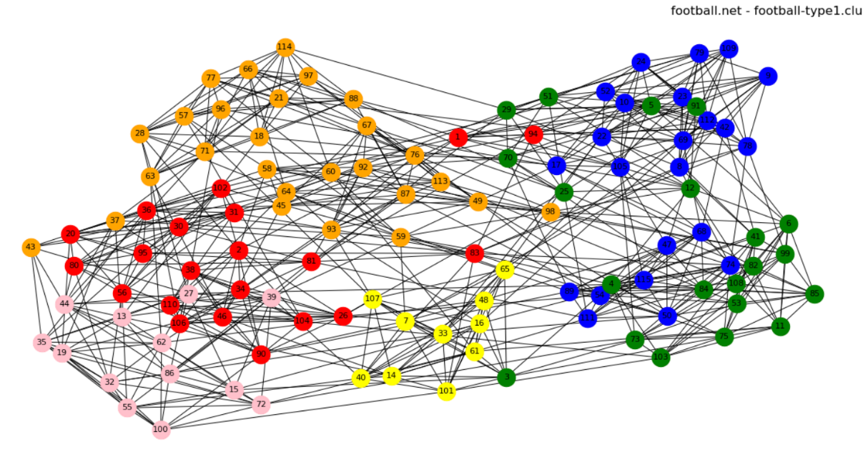

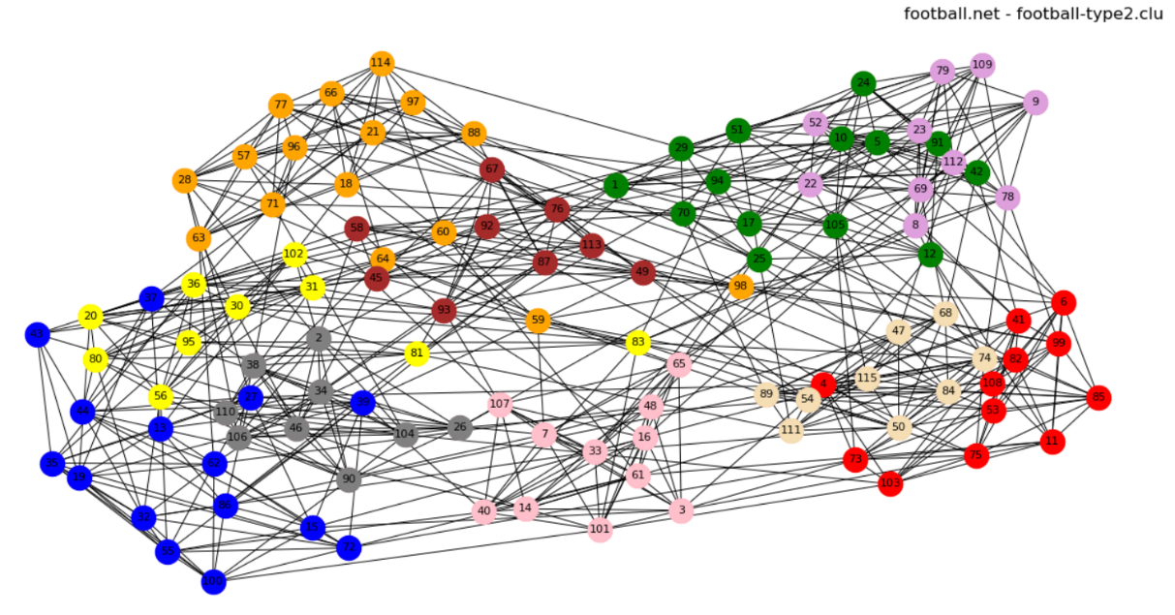

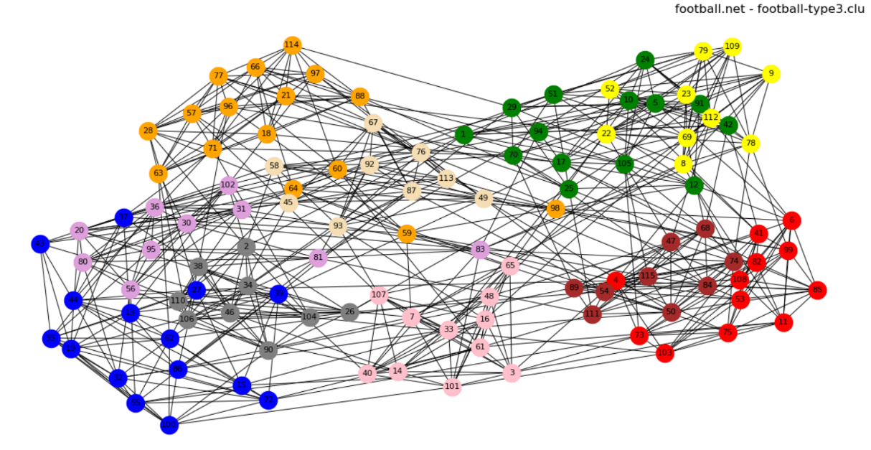

**dolphins**

***Modularity***

|  |  |
| --- | --- |
| dolphins-real.clu | 0.96226415 |
| dolphins -type1.clu | 0.82389937 |
| dolphins -type2.clu | 0.80503145 |
| dolphins -type3.clu | 0.74842767 |

***Indexes***

*Jaccard Index*

|  |  |  |  |
| --- | --- | --- | --- |
|  | dolphins-type1.clu | dolphins-type2.clu | dolphins-type3.clu |
| dolphins-real.clu | 0.5041 | 0.4547 | 0.3688 |

*Normalized Mutual Information*

|  |  |  |  |
| --- | --- | --- | --- |
|  | dolphins-type1.clu | dolphins-type2.clu | dolphins-type3.clu |
| dolphins-real.clu | 0.5727 | 0.5792 | 0.5124 |

*Normalized Variation of Information*

|  |  |  |  |
| --- | --- | --- | --- |
|  | dolphins-type1.clu | dolphins-type2.clu | dolphins-type3.clu |
| dolphins-real.clu | 0.1883 | 0.1986 | 0.2565 |

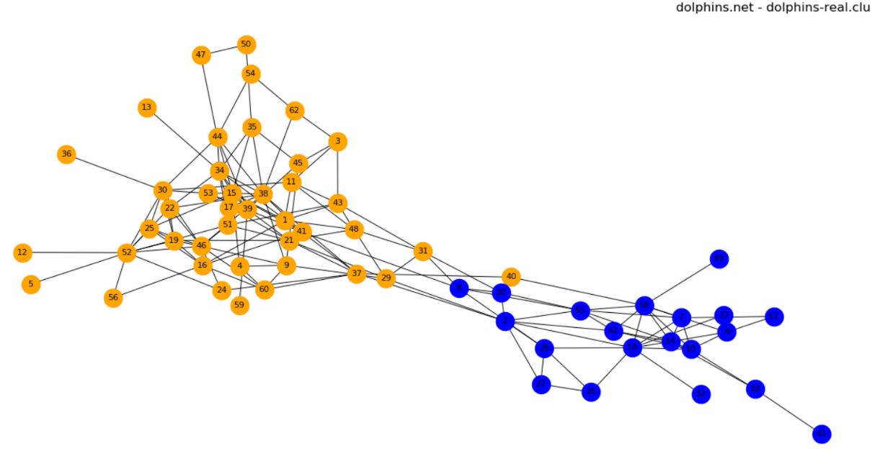***Images***

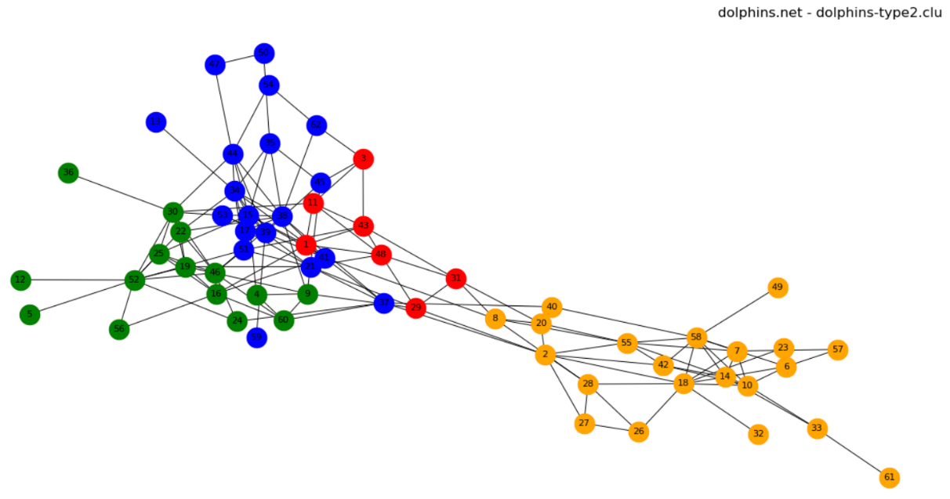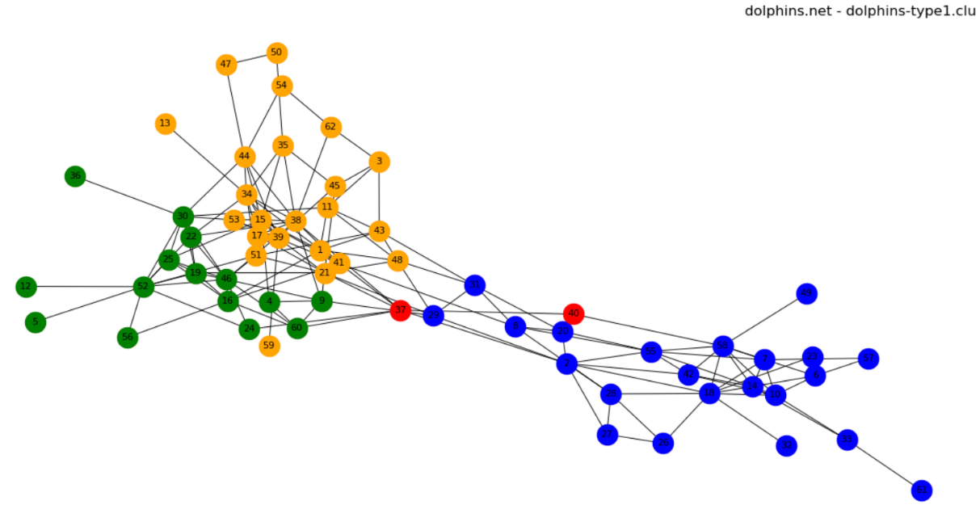

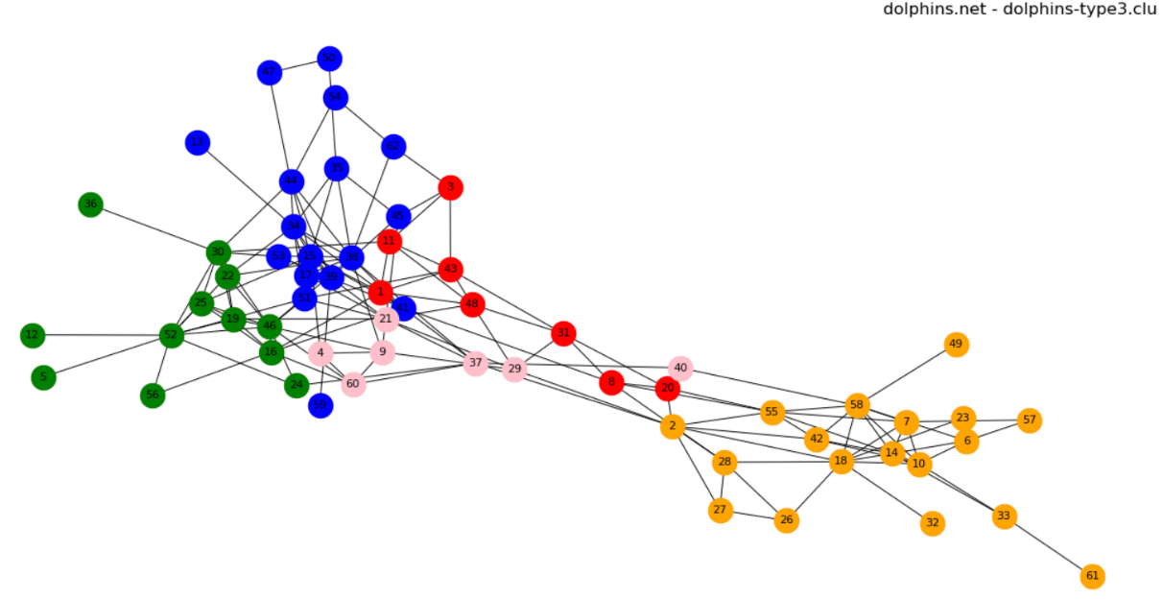

**zachary_unwh**

***Modularity***

|  |  |
| --- | --- |
| zachary_unwh-real.clu | 0.87179487 |
| zachary_unwh-type1.clu | 0.75641026 |
| zachary_unwh-type2.clu | 0.73076923 |
| zachary_unwh-type3.clu | 0.73076923 |

***Indexes***

*Jaccard Index*

|  |  |  |  |
| --- | --- | --- | --- |
|  | zachary_unwh-type1.clu | zachary_unwh-type2.clu | zachary_unwh-type3.clu |
| zachary_unwh-real.clu | 0.6833 | 0.5348 | 0.5348 |

*Normalized Mutual Information*

|  |  |  |  |
| --- | --- | --- | --- |
|  | zachary_unwh-type1.clu | zachary_unwh-type2.clu | zachary_unwh-type3.clu |
| zachary_unwh-real.clu | 0.6925 | 0.6873 | 0.6873 |

*Normalized Variation of Information*

|  |  |  |  |
| --- | --- | --- | --- |
|  | zachary_unwh-type1.clu | zachary_unwh-type2.clu | zachary_unwh-type3.clu |
| zachary_unwh-real.clu | 0.1509 | 0.1784 | 0.1784 |

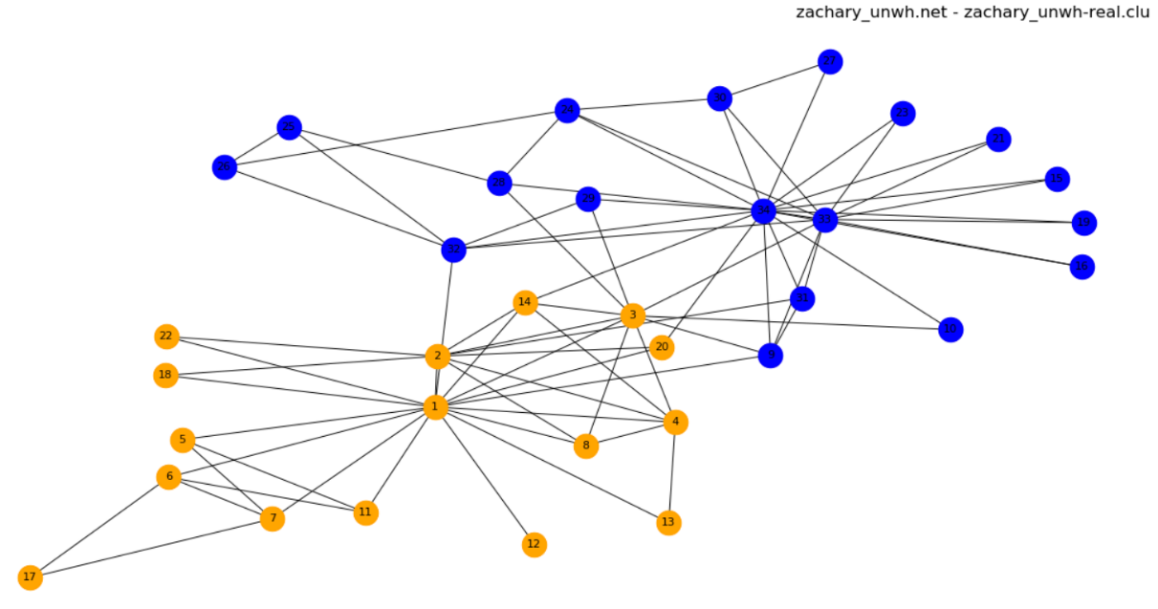***Images***

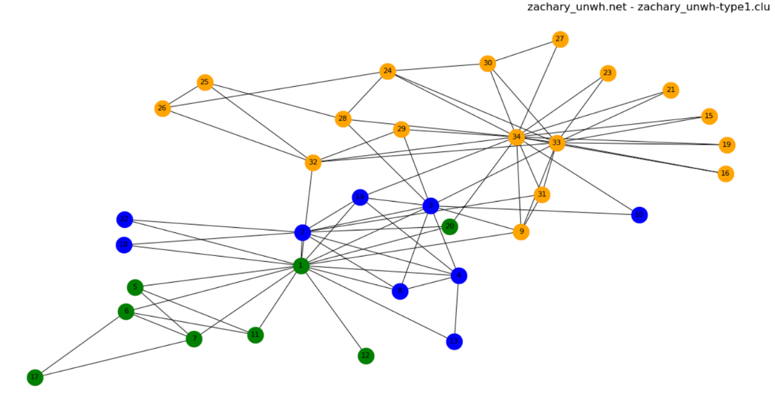

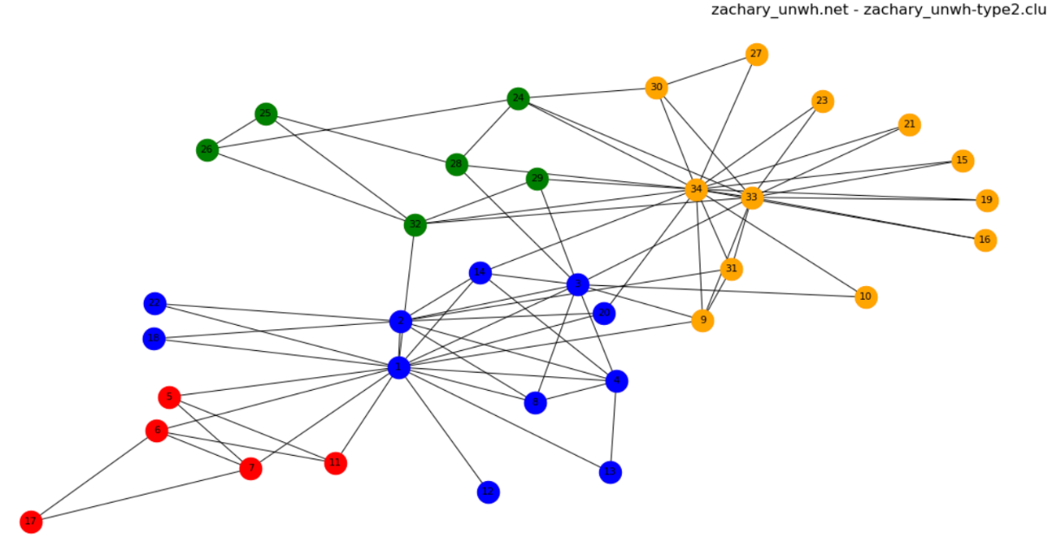

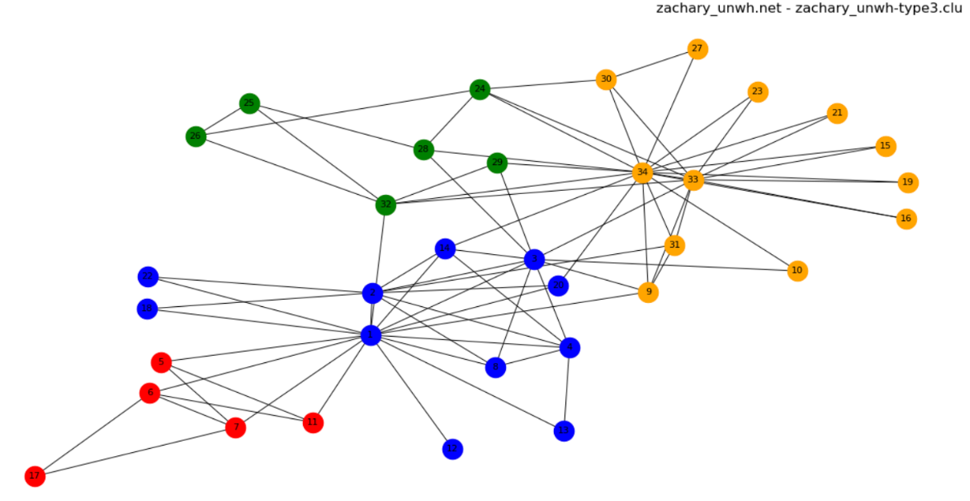

**20x2+5x2**

***Modularity***

|  |  |
| --- | --- |
| 20x2+5x2.clu | 0.99009901 |
| 20x2+5x2-type1.clu | 0.99257426 |
| 20x2+5x2-type2.clu | 0.99257426 |
| 20x2+5x2-type3.clu | 0.99257426 |

***Indexes***

*Jaccard Index*

|  |  |  |  |
| --- | --- | --- | --- |
|  | 20x2+5x2-type1.clu | 20x2+5x2-type2.clu | 20x2+5x2-type3.clu |
| 20x2+5x2.clu | 0.9412 | 0.9412 | 0.9412 |

*Normalized Mutual Information*

|  |  |  |  |
| --- | --- | --- | --- |
|  | 20x2+5x2-type1.clu | 20x2+5x2-type2.clu | 20x2+5x2-type3.clu |
| 20x2+5x2.clu | 0.9383 | 0.9383 | 0.9383 |

*Normalized Variation of Information*

|  |  |  |  |
| --- | --- | --- | --- |
|  | 20x2+5x2-type1.clu | 20x2+5x2-type2.clu | 20x2+5x2-type3.clu |
| 20x2+5x2.clu | 0.0354 | 0.0354 | 0.0354 |

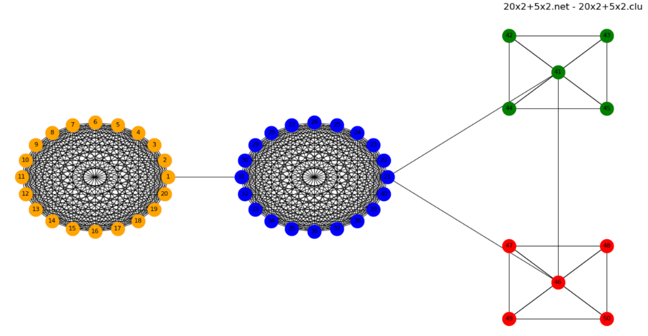***Images***

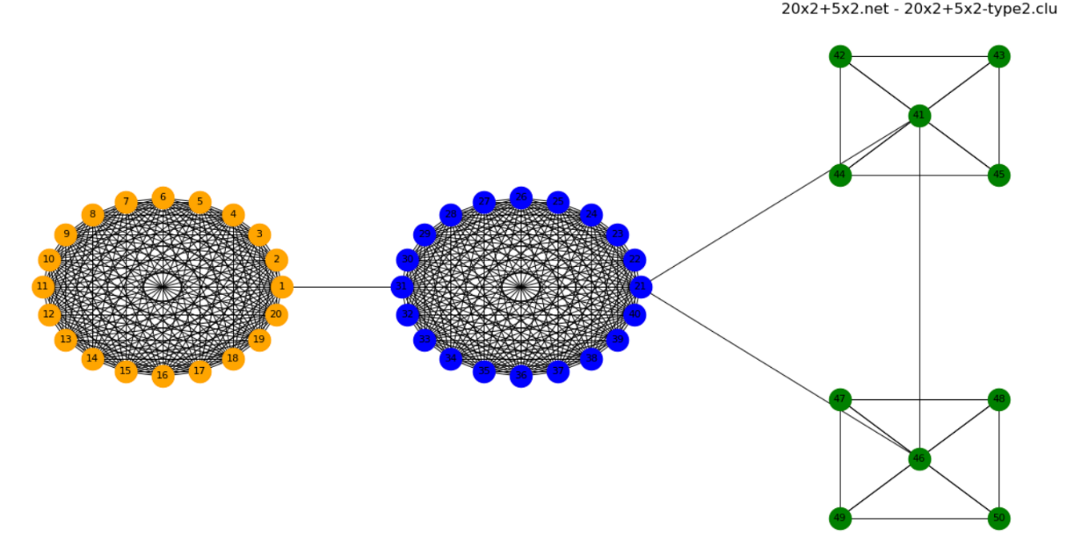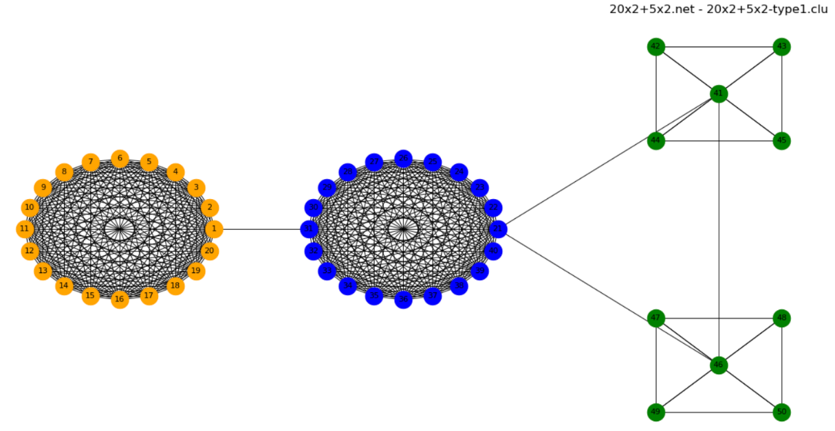

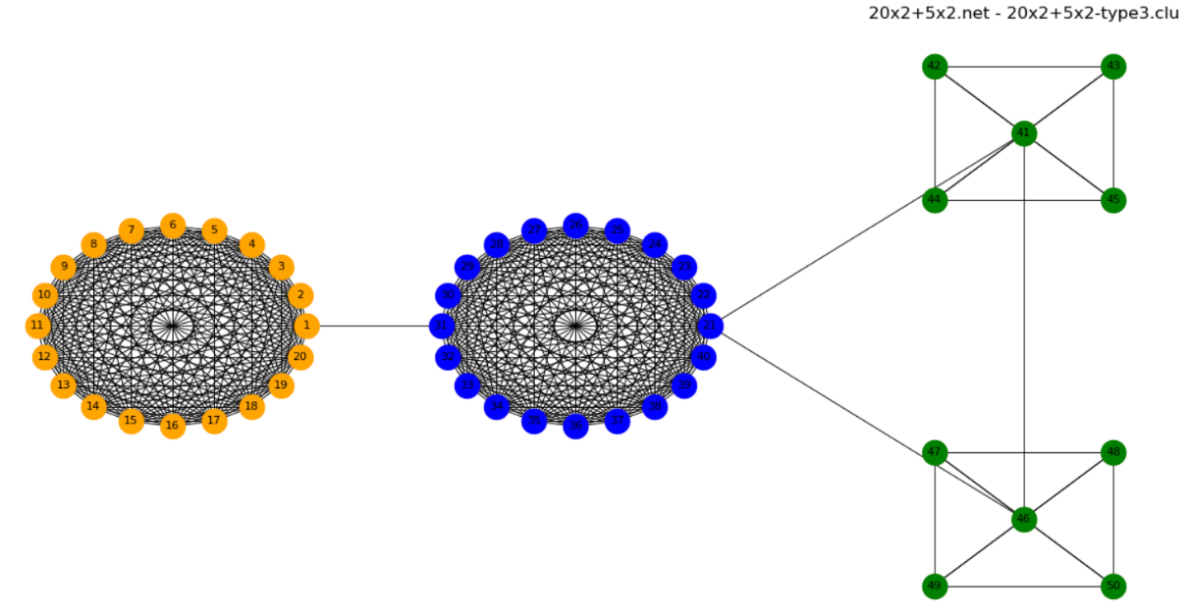

**graph4+4**

***Modularity***

|  |  |
| --- | --- |
| graph4+4.clu | 0.94285714 |
| graph4+4-type1.clu | 0.94285714 |
| graph4+4-type2.clu | 0.94285714 |
| graph4+4-type3.clu | 0.82857143 |

***Indexes***

*Jaccard Index*

|  |  |  |  |
| --- | --- | --- | --- |
|  | graph4+4-type1.clu | graph4+4-type2.clu | graph4+4-type3.clu |
| graph4+4.clu | 1.0000 | 1.0000 | 0.4615 |

*Normalized Mutual Information*

|  |  |  |  |
| --- | --- | --- | --- |
|  | graph4+4-type1.clu | graph4+4-type2.clu | graph4+4-type3.clu |
| graph4+4.clu | 1.0000 | 1.0000 | 0.5856 |

*Normalized Variation of Information*

|  |  |  |  |
| --- | --- | --- | --- |
|  | graph4+4-type1.clu | graph4+4-type2.clu | graph4+4-type3.clu |
| graph4+4.clu | 0.0000 | 0.0000 | 0.3538 |

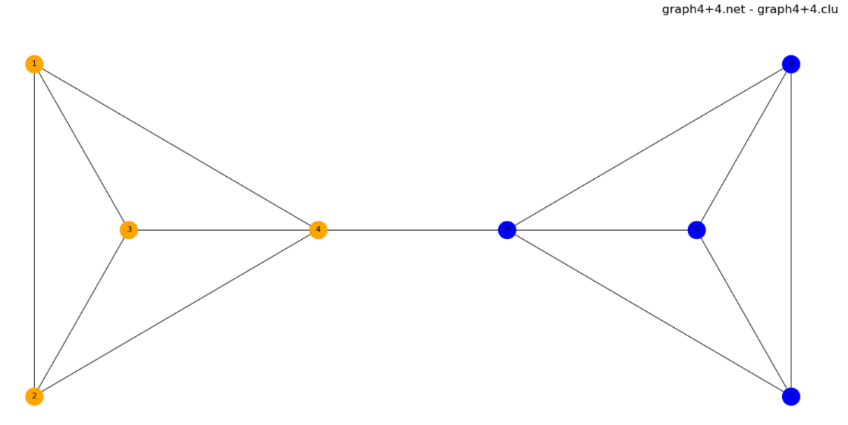***Images***

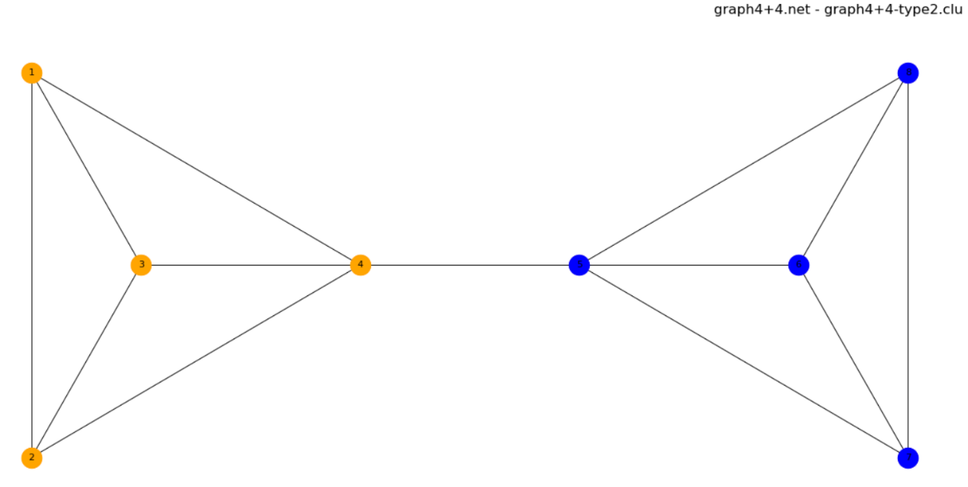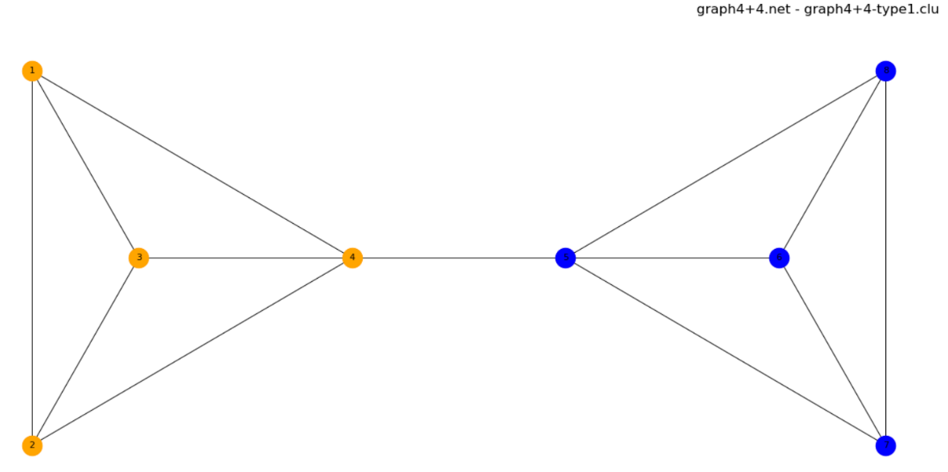

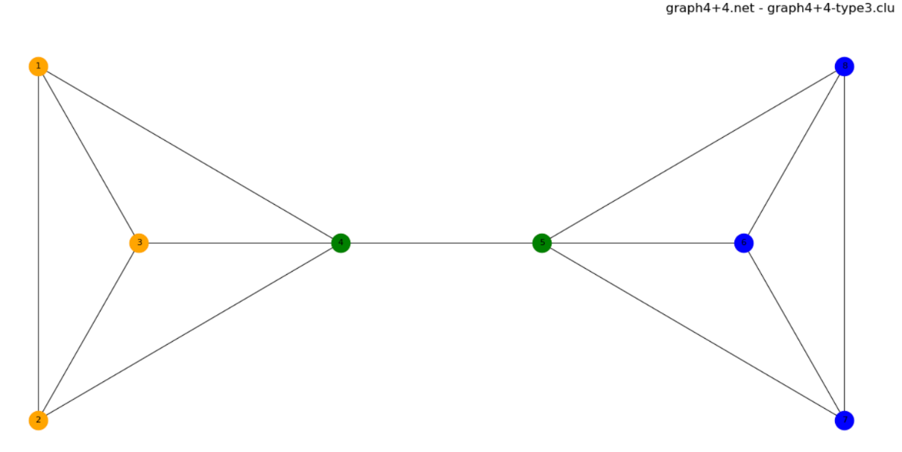

**graph3+1+3**

***Modularity***

|  |  |
| --- | --- |
| graph3+1+3.clu | 0.75000000 |
| graph3+1+3-type1.clu | 0.87500000 |
| graph3+1+3-type2.clu | 0.87500000 |
| graph3+1+3-type3.clu | 0.87500000 |

***Indexes***

*Jaccard Index*

|  |  |  |  |
| --- | --- | --- | --- |
|  | graph3+1+3-type1.clu | graph3+1+3-type2.clu | graph3+1+3-type3.clu |
| graph3+1+3.clu | 0.6667 | 0.6667 | 0.6667 |

*Normalized Mutual Information*

|  |  |  |  |
| --- | --- | --- | --- |
|  | graph3+1+3-type1.clu | graph3+1+3-type2.clu | graph3+1+3-type3.clu |
| graph3+1+3.clu | 0.8095 | 0.8095 | 0.8095 |

*Normalized Variation of Information*

|  |  |  |  |
| --- | --- | --- | --- |
|  | graph3+1+3-type1.clu | graph3+1+3-type2.clu | graph3+1+3-type3.clu |
| graph3+1+3.clu | 0.1651 | 0.1651 | 0.1651 |

***Images***





**grid-p-6x6**

***Modularity***

|  |  |
| --- | --- |
| grid-p-6x6-type1.clu | 0.58333333 |
| grid-p-6x6-type2.clu | 0.75000000 |
| grid-p-6x6-type3.clu | 0.75000000 |

***Indexes***

No comparisons because this network has no .clu files given as input of exercise

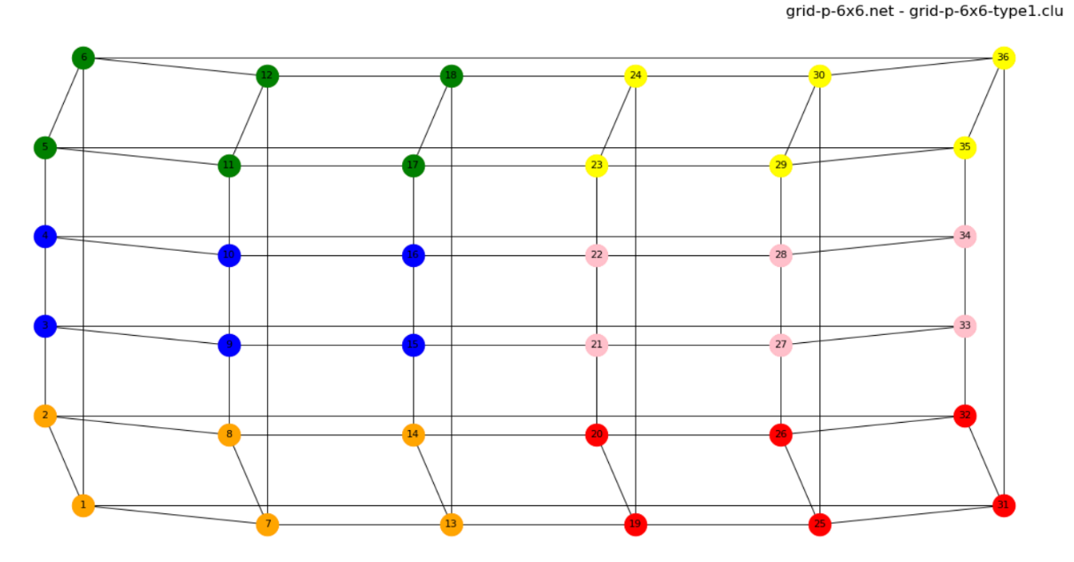***Images***

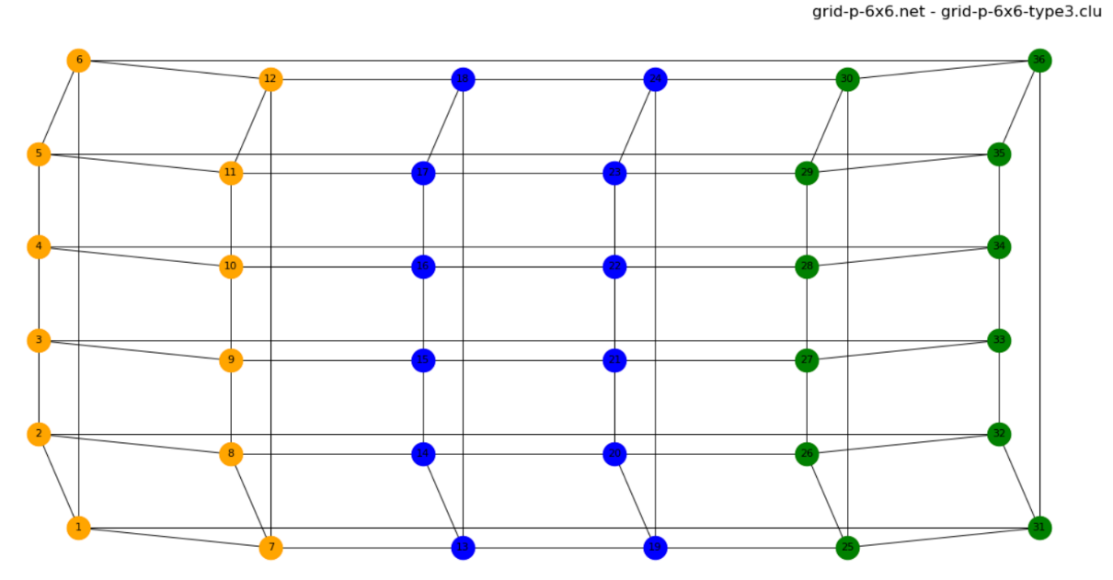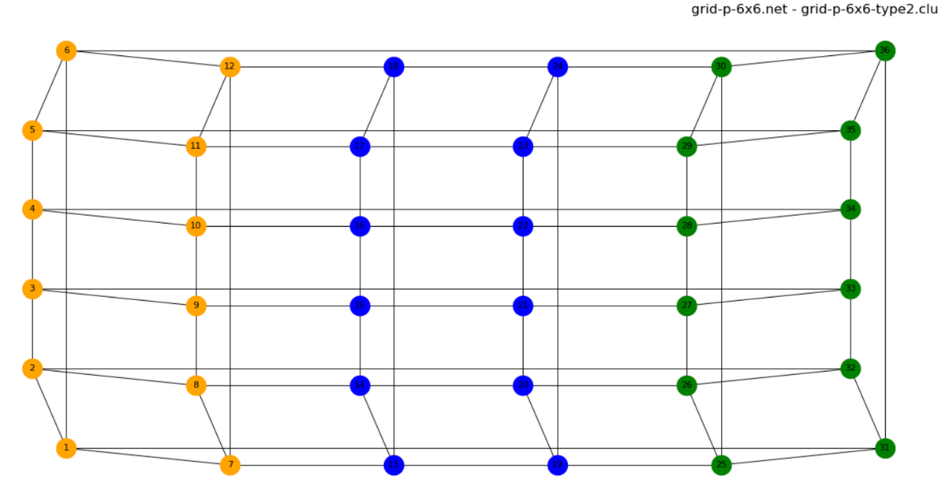

**star**

***Modularity***

|  |  |
| --- | --- |
| star.clu | 1.00000000 |
| star-type1.clu | 1.00000000 |
| star-type2.clu | 1.00000000 |
| star-type3.clu | 1.00000000 |

***Indexes***

*Jaccard Index*

|  |  |  |  |
| --- | --- | --- | --- |
|  | star-type1.clu | star-type2.clu | star-type3.clu |
| star.clu | 1.0000 | 1.0000 | 1.0000 |

*Normalized Mutual Information*

|  |  |  |  |
| --- | --- | --- | --- |
|  | star-type1.clu | star-type2.clu | star-type3.clu |
| star.clu | 1.0000 | 1.0000 | 1.0000 |

*Normalized Variation of Information*

|  |  |  |  |
| --- | --- | --- | --- |
|  | star-type1.clu | star-type2.clu | star-type3.clu |
| star.clu | 0.0000 | 0.0000 | 0.0000 |

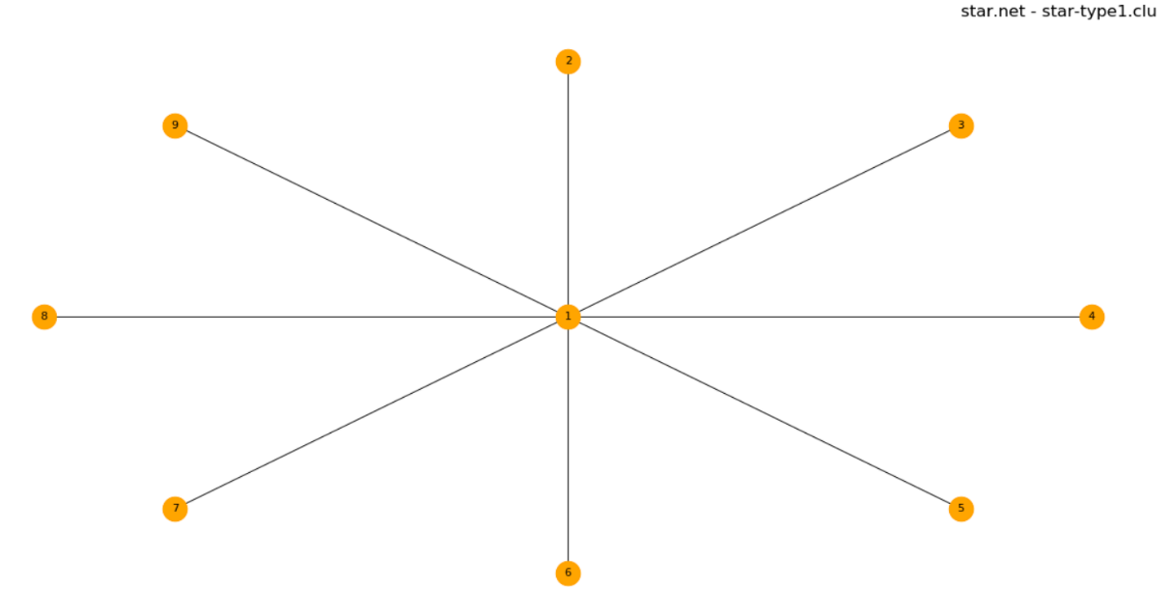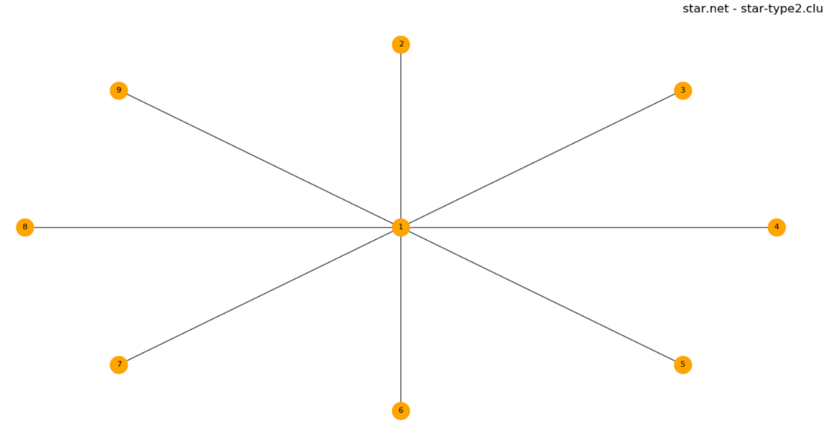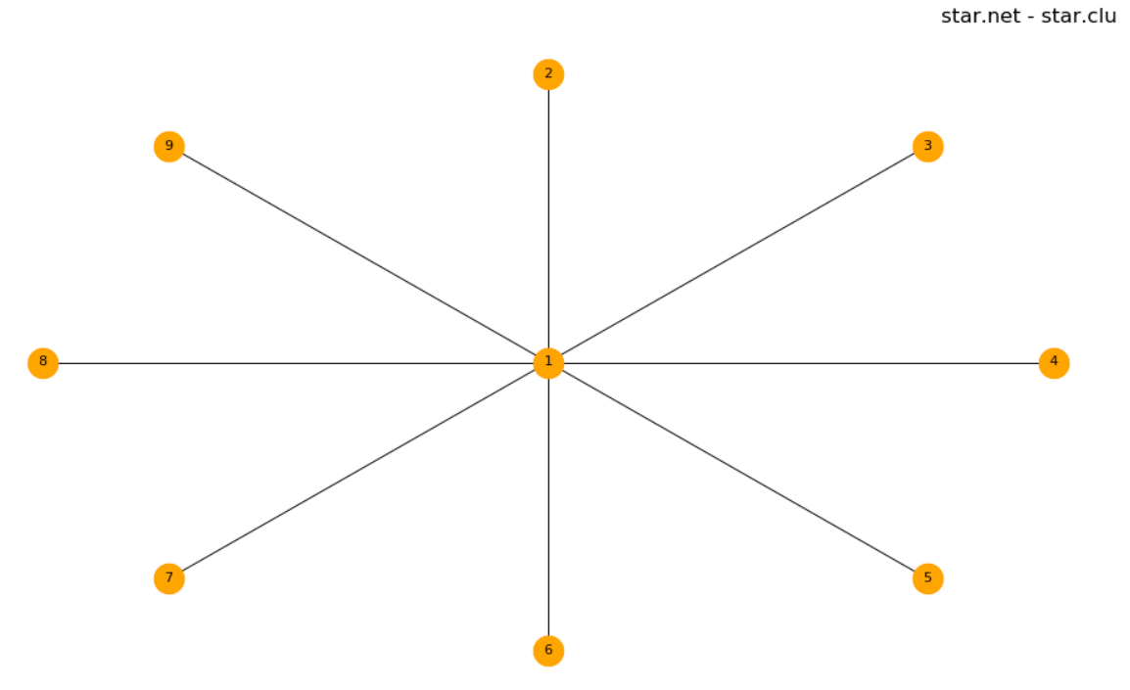***Images***

